**Q14. Weather Observation Station 9**

Query the list of CITY names from STATION that do not start with vowels. Your result cannot contain duplicates.

The STATION table is described as follows: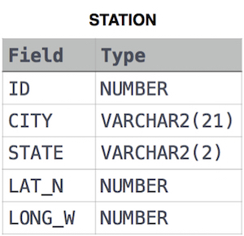

Ans.

SELECT DISTINCT CITY

FROM STATION

WHERE LEFT(CITY, 1) NOT IN ('A', 'E', 'I', 'O', 'U');

**OR**

SELECT DISTINCT(CITY)

FROM STATION

WHERE LOWER(CITY) REGEXP '^[^aeiou]'